|  |  |  |  |  |
| --- | --- | --- | --- | --- |
|  |  |  |  |  |
|  |  |  |  |  |
|  |  |  |  |  |

Table

Style 1

Style 2

|  |  |  |  |  |
| --- | --- | --- | --- | --- |
|  |  |  |  |  |
|  |  |  |  |  |

|  |  |  |  |  |  |  |  |  |  |  |  |  |
| --- | --- | --- | --- | --- | --- | --- | --- | --- | --- | --- | --- | --- |
|  | |  | | | |  | |  | | |  | |
|  | |  | | | |  | |  | | |  | |
|  |  | |  |  |  | |  | |  |  | |  |
|  | |  | | | |  | |  | | |  | |
|  | |  | | | |  | |  | | |  | |

Style 3

|  |  |  |  |  |  |  |
| --- | --- | --- | --- | --- | --- | --- |
|  |  |  |  |  |  |  |
|  |  |  |  |  |  |  |
|  |  |  |  |  |  |  |

Style 4

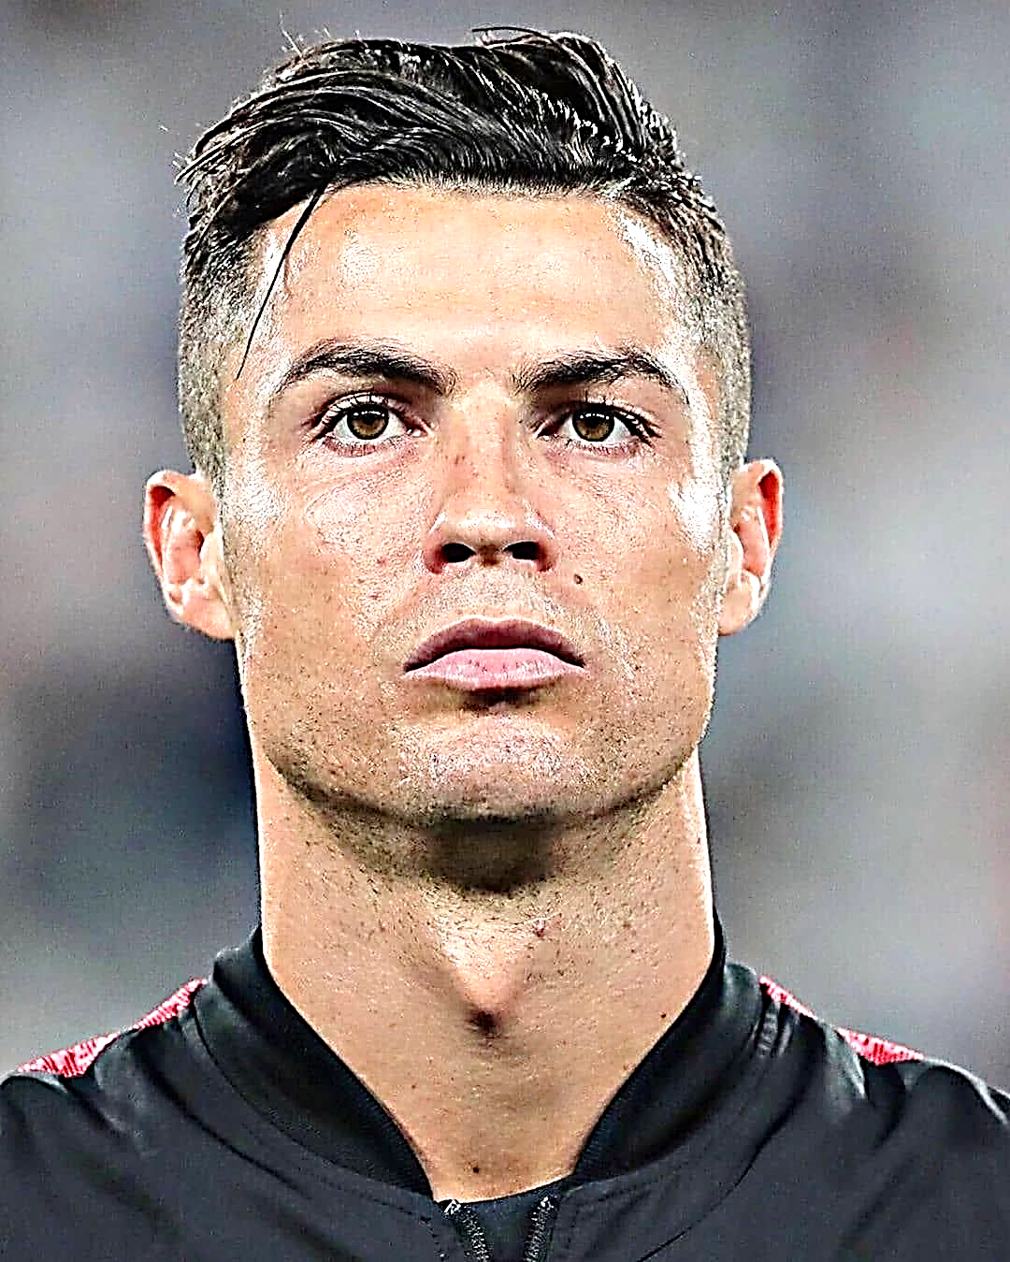

Style 5